These projects include Compute, Identity Service, Networking, Image Service, Block Storage, Object Storage, Telemetry, Orchestration, and Database.

Automation tools such as Ansible, Chef, and Puppet

Dashboard => Horizon

Compute => Nova

Networking => Neutron

Object Storage => Swift

Block Storage => Cinder

Identity service => Keystone

Image Service => Glance

Telemetry => Ceilometer

Orchestration => Heat

Database Service => Trove

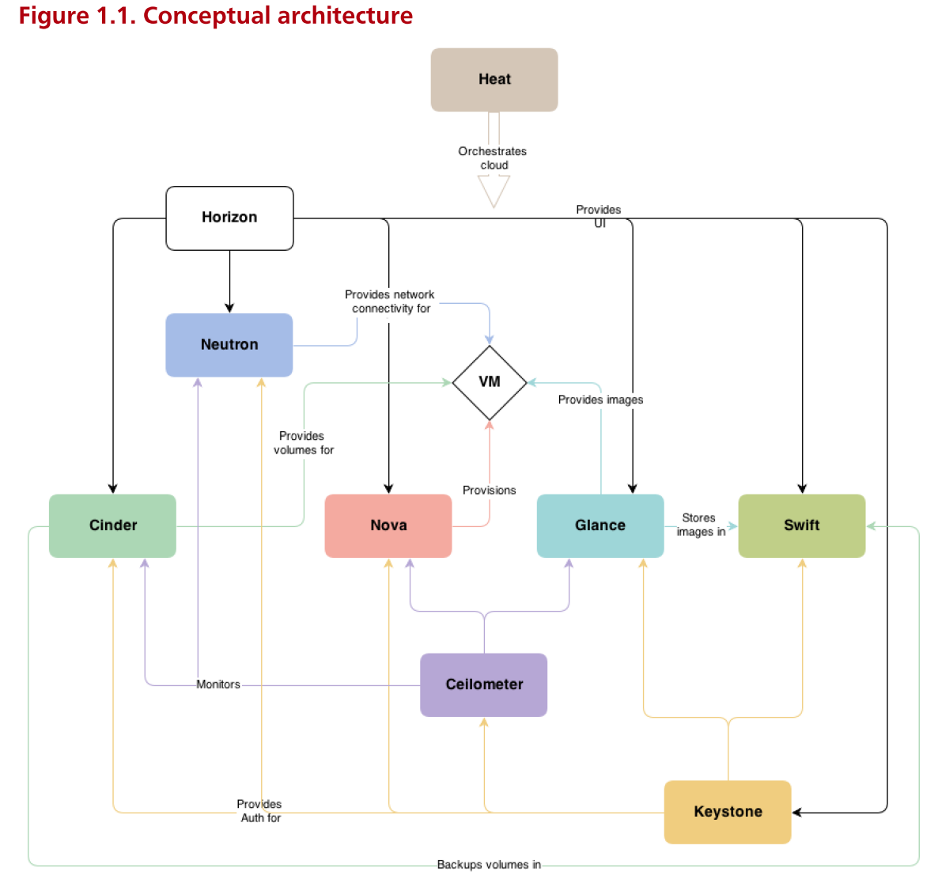

sudo adduser stack

sudo usermod –a –G sudo stack

sudo apt-get install git –y

git clone https://git.openstack.org/openstack-dev/devstack

sudo visudo

stack ALL=(ALL:ALL) NOPASSWD: ALL